

Fall 2025 Midterm Exam
MSDS 400: Math for Modelers

Points possible: 100

Description: The midterm exam will cover topics from sessions 1-4.

Resources: The exam is completely open book. You may use course textbooks, materials provided on Canvas, Python (encouraged…just be sure to include the relevant code), and basic calculators; but any more advanced calculators, Excel Solver, Web calculators, Web-graphic calculators, or simplex method calculators are not allowed. Programming languages other than Python are also not permitted. All Python work must be your own and must be completed using Jupyter, Spyder or VS Code. The use of other IDEs or other assistance writing your code, such as ChatGPT or other AI tools is not permitted. If you want to cheat on this, you will only be cheating yourself.

For questions that require calculations, all calculations should be shown, not just the final answer. This will allow for partial credit for those answers that might be set up correctly but have calculation errors. For questions that specifically require Python, the code and output should be included with your answer. For questions that require graphs, only use Python.

Restrictions: All answers are to be your work only. You are not to receive assistance from any other person.

To complete the exam:

1. Answer all questions on the exam thoroughly. Create a Microsoft Word document, including the question number, the question, your typed answer, and graphs if required. You may use Word’s equation editor to complete your answers.

2. Once you have completed your exam, return to the exam item where you downloaded the exam PDF, click View/Complete Assignment, and submit your document.

- GoBull along with TB13 is designing a new type of Crossfit shoe, the NANO CLXII. The fixed cost for the production will be $50,000. The variable cost will be $18 per pair of shoes. The shoes will sell for $130 for each pair. Graph the cost and revenue functions – either by hand or with Python -- and determine how many pairs of sneakers will have to be sold for the company to break even on this new line of shoes.

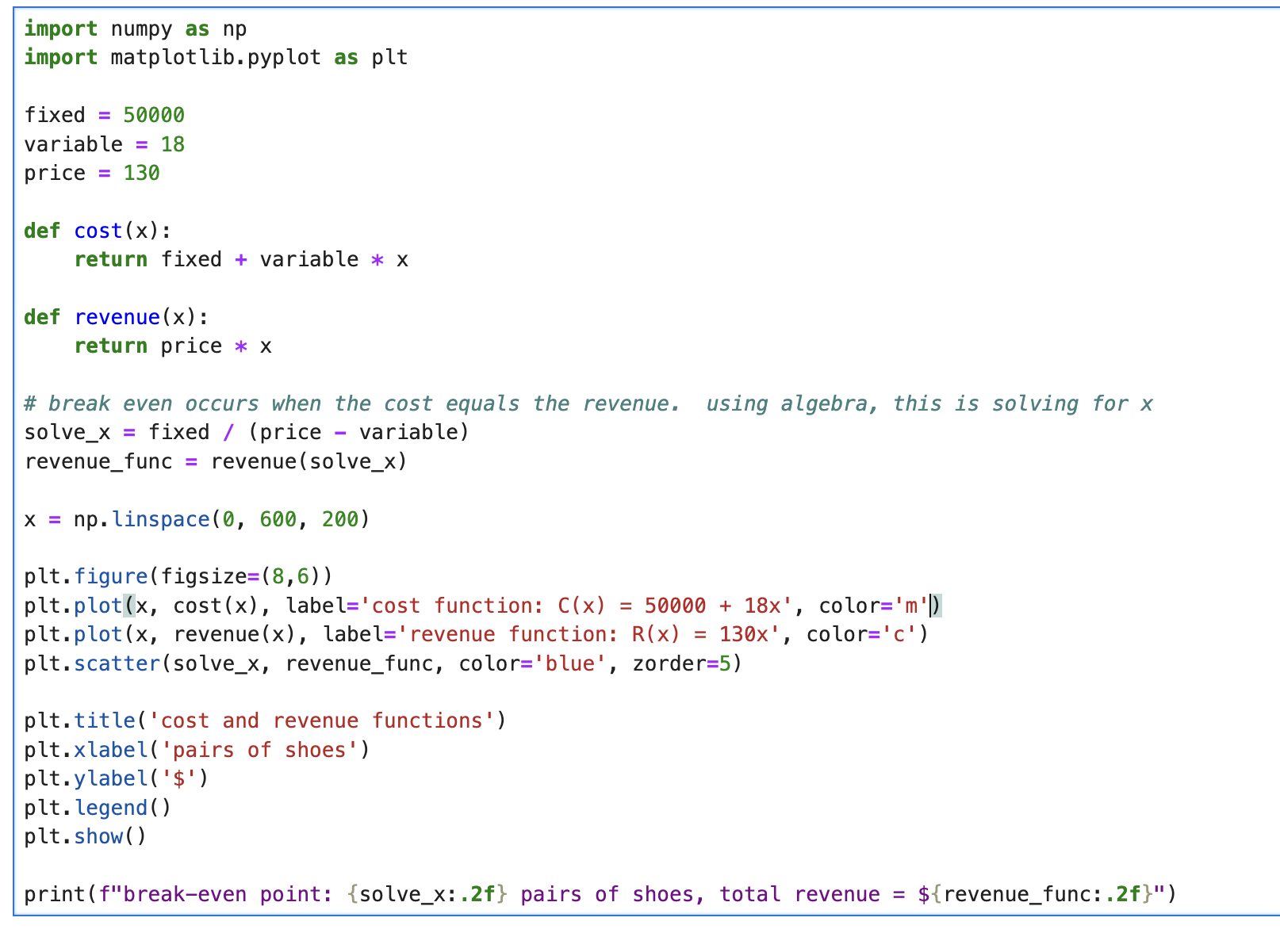
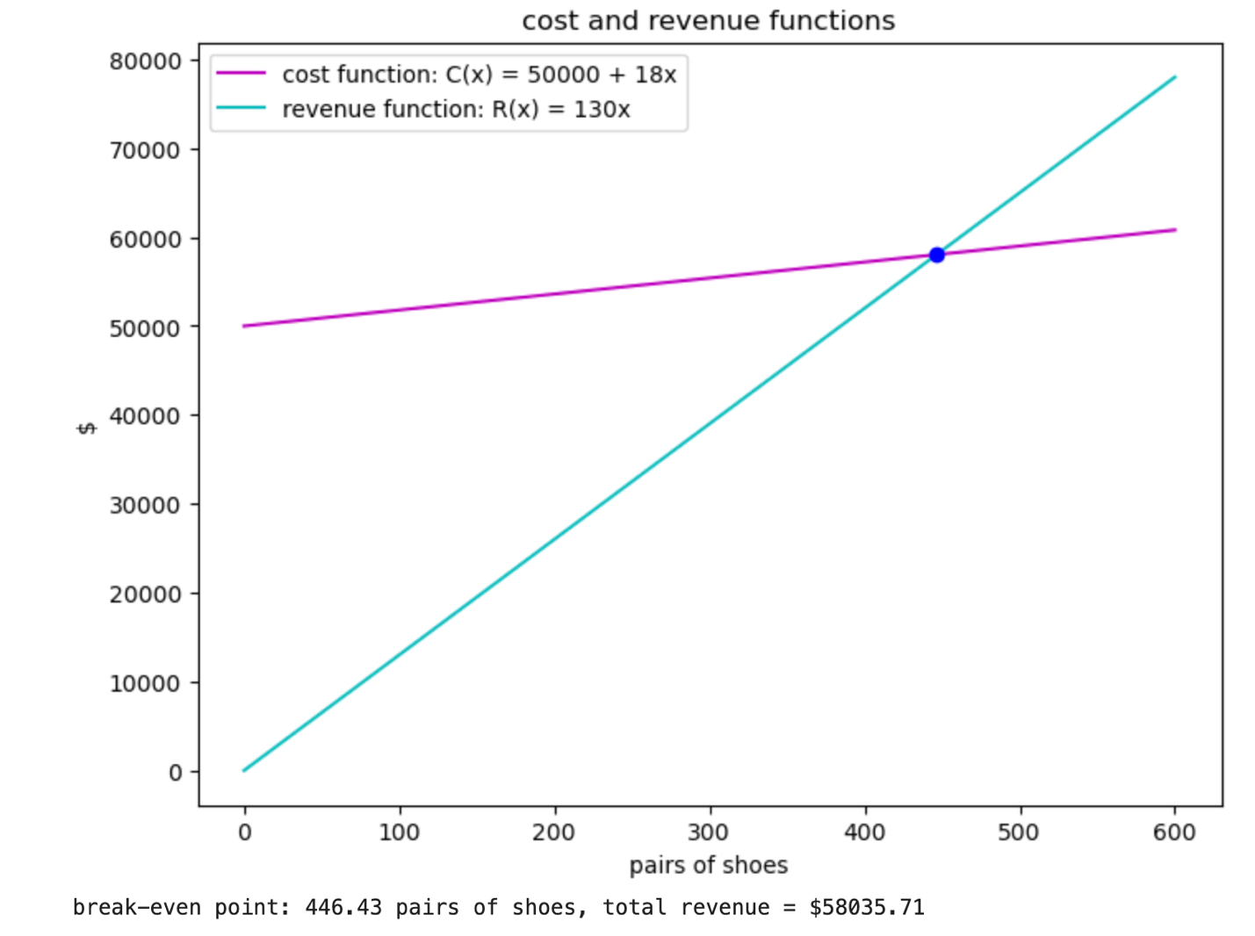

- Elon invests a total of $17,500,000,000 in three products. He invests one part in a mutual fund which has an annual return of 11%. He invests the second part in government bonds at 7% per year. The third part he puts in DOGE at 5% per year. He invests twice as much in the mutual fund as in the DOGE. In the first year Elon’s investments bring a total return of $1,495,000,000. How much did he invest in each product?

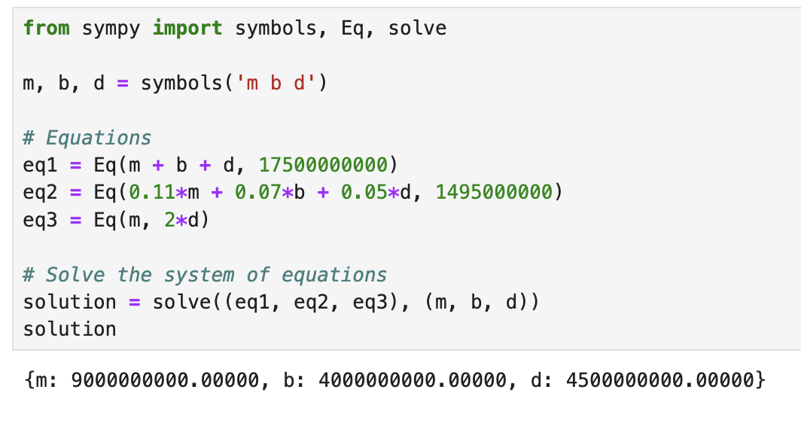
m is mutual fund, b is bond, d is doge

- Vandelay Industries has 275 sales reps in order to sell its latex products, each to be assigned to one of four marketing teams. If the first team is to have four times as many members as the second team and the third team is to have five times as many members as the fourth team, how can the members be distributed among the teams?

Team 1 = 4x
Team 2 = x
Team 3 = 5y
Team 4 = y

So we can write the equation as: 4x + x + 5y + y = 275. We can simplify that to make it 5x + 6y = 275.

Solving for x we get x = (275-6y) / 5

Since the denominator is 5, we want the numerator to be 5 or greater and also be divisible by 5 in order to have a whole integer which is a whole person. If we do (275-6y) % 5 =

We know that y has to be a multiple of 5 because 275 mod 5 is 0, but we have to get 6y % 5 to be 0 as well. So that’s why y has to be multiplied by the very least 5 and then by multiples of 5 so 5, 10, 15, 20 etc.

Let’s set y equal to 5 and substitute it back into the equation for x:

x = (275 – 6*5) / 5 = (275-30) / 5 = 49

Since we already declared that y is 5 and now we solved for x as 49, we can substitute it back into our original equation.

4(49) + 49 + 5(5) + 5 = 275
196 + 49 + 25 + 5 = 275
Each of these numbers corresponds to a team so:
Team 1 = 196
Team 2 = 49
Team 3 = 25
Team 4 = 5

- Willie W’s Candy makes three types of artisanal, single-batch, organic, vegan, gluten free, cruelty-free, fun-free, fair-trade brownies: cherry, almond, and raisin. Matrix A gives the amount of ingredients in one batch. Matrix B gives the costs of ingredients from suppliers J and K. Calculate the cost of 100 batches of each candy using ingredients from supplier K.
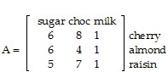
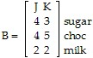
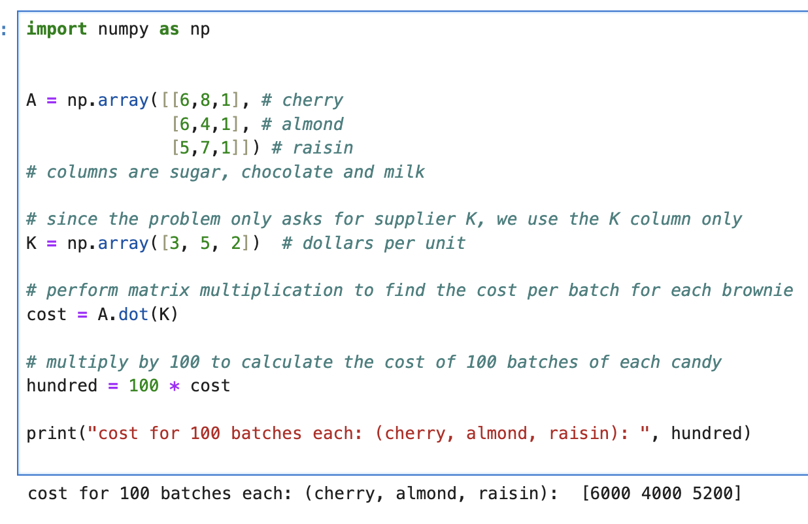
- After its new renovations funded by donations from graduates of this program, MSDS400 Arena (still workshopping that name) will seat 28,000 people. Courtside seats cost $48, first level seats cost $36, and upper deck seats cost $24. The total revenue for a sellout is $750,000. If half the courtside seats, half the upper deck seats, and all the first level seats are sold, then the total revenue is $400,000. How many of each type of seat are there? Round your answers as needed.

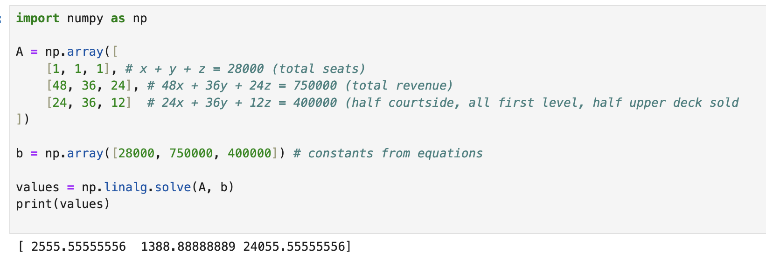
since there can only be whole integers for seats, we round down to get the following answers:
Court side: 2555
First level: 1388
Upper deck: 24055

- Due to new environmental restrictions, Hoch Industries must use a new process to reduce pollution. The old process emits 6 g of CO₂ and 3 g of lead per liter of chemical made. The new process emits 2 g of CO₂ and 4 g of lead per liter of chemical made. The company makes a profit of 25¢ per liter under the old process and 16¢ per liter under the new process. No more than 18,000 g of CO₂ and no more than 12,000 g of lead can be emitted daily. How many liters of chemicals should be made daily under each process to maximize profits? What is the maximum profit?

x = liters old process
y = liters new process

objective function:
P = 0.25x + 0.16y

constraints:
6x + 2y <= 18000
3x + 4y <= 12000
x >= 0
y >= 0

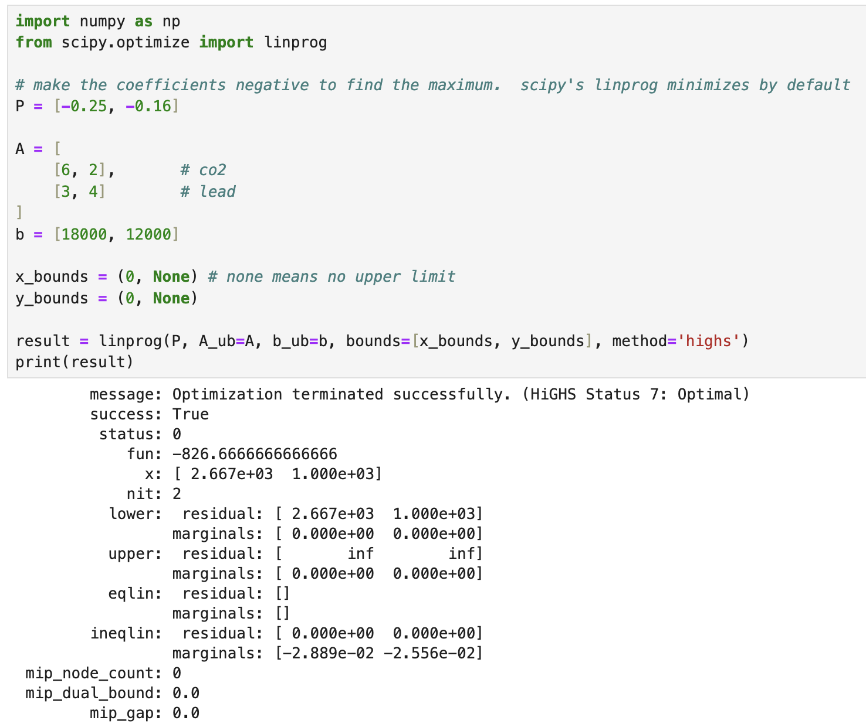

The result is a negative number for the maximum profit so we just reverse that to make it positive. So the maximum profit is $826.67 and there should be 2667 liters under the old process and 1000 liters under the new process.

- Northwestern is looking to hire teachers and TAs to fill its staffing needs for its summer program at minimum cost. The average monthly salary of a teacher is $2400 and the average monthly salary of a TA is $1100. The program can accommodate up to 45 staff members, needs at least 30 to run properly, and must have teachers (they will NOT employee only TAs…as much as it makes purely economic sense). They must have at least 10 TAs and may have up to 3 TA’s for every 2 teachers. How many teachers and TAs the should the program hire to minimize costs. What is the minimum cost?

C = 2400t + 1100a
a >= 10
t >= 1
t + a <= 45
t + a >= 30
a <= 3/2 t
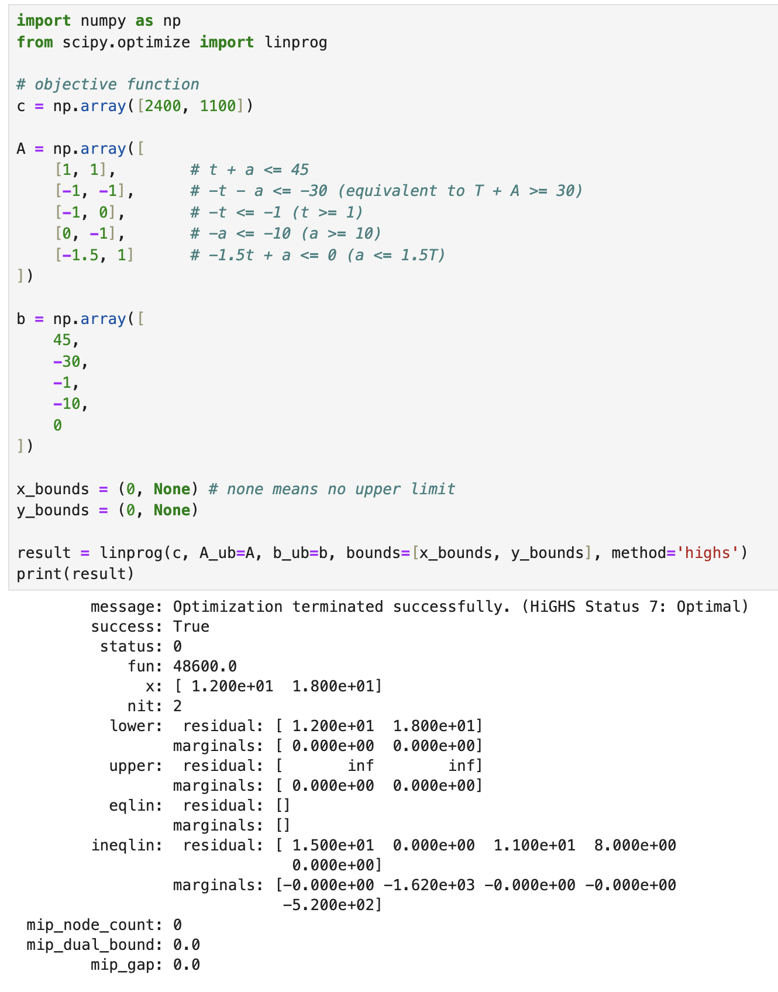
The minimum cost is $48600 and the number of teachers is 12 and number of TA’s is 18.
- To be at his best as an athlete/owner/announcer, Tom needs at least 10 units of nutrient A, 12 units of nutrient B, and 20 units of nutrient C per day. Pill #1 contains 4 units of A and 3 of B. Pill #2 contains 1 unit of A, 2 of B, and 4 of C. Pill #3 contains 10 units of A, 1 of B, and 5 of C. Pill #1 costs 6 cents, pill #2 costs 8 cents, and pill #3 costs 1 cent. How many of each pill must he take to minimize his cost, and what is that cost?

a = pill 1
b = pill 2
c = pill 3

objective function:
d = 0.06a + 0.08b + 0.01c

constraints:
all greater than 0
4a + b + 10c >= 10
3a + 2b + c >= 12
4a + 5b >= 20

Multiply all by -1 to constraint equations to get <= for linprog
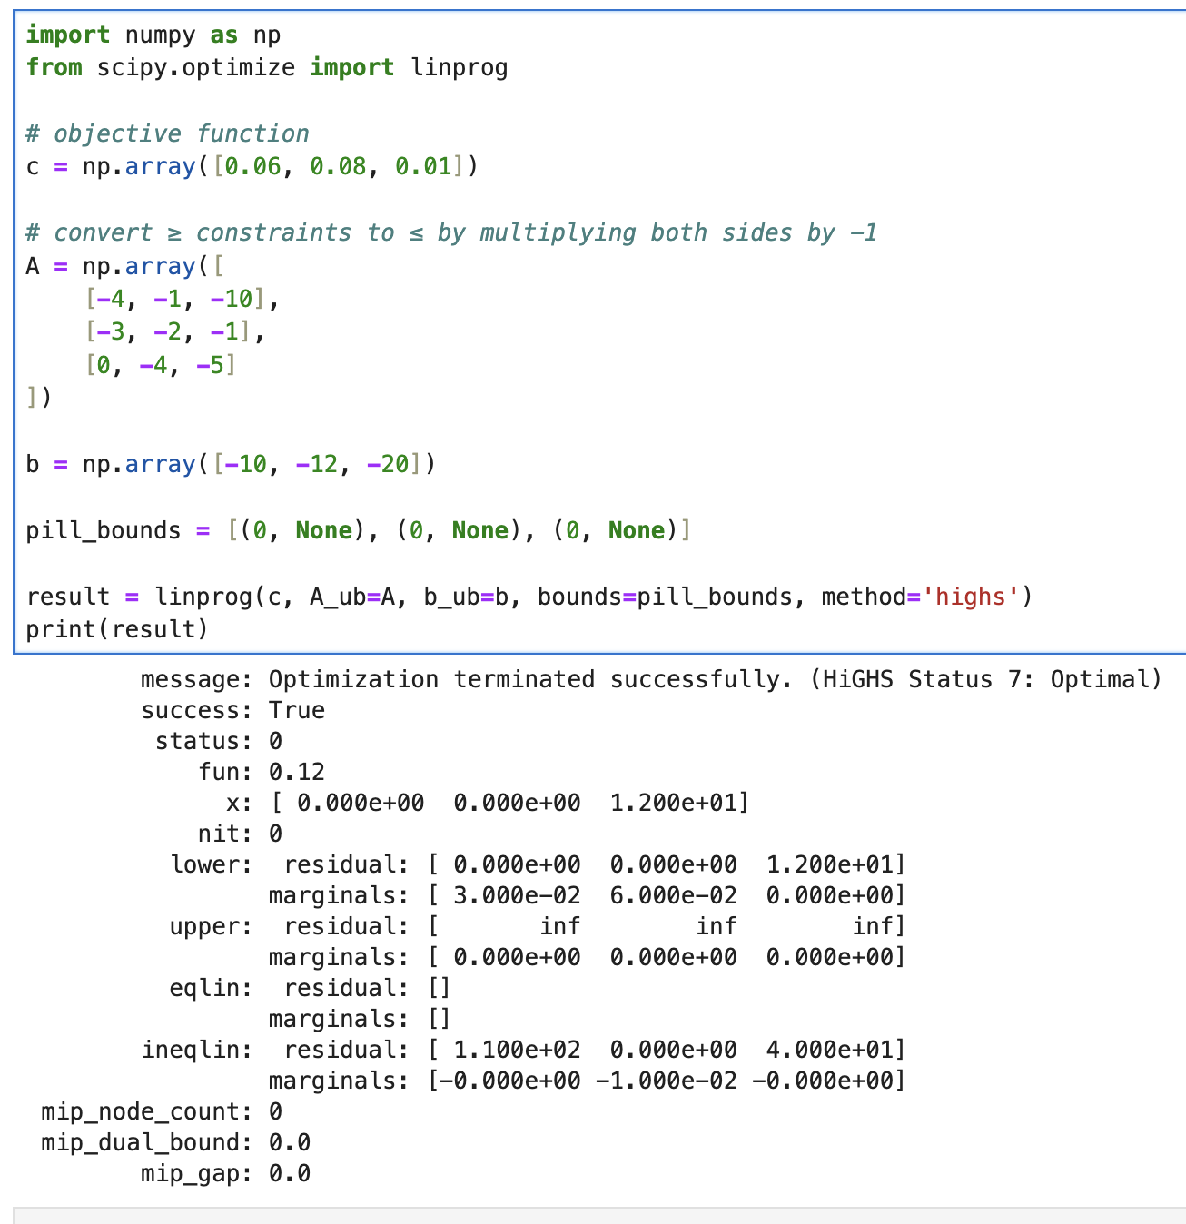
the minimum cost is 12 cents and he must take 0 pills of pill 1, 0 pills of pill 2 and 12 pills of pill 3.
- The population of applied mathematicians in Southeast Evanston is given by the formula P(t) = (t² + 100)·ln(t + 2), where t represents the time in years since 2000. Find the rate of change of this population in 2006 and again in 2016. At what point do you believe this model breaks down?

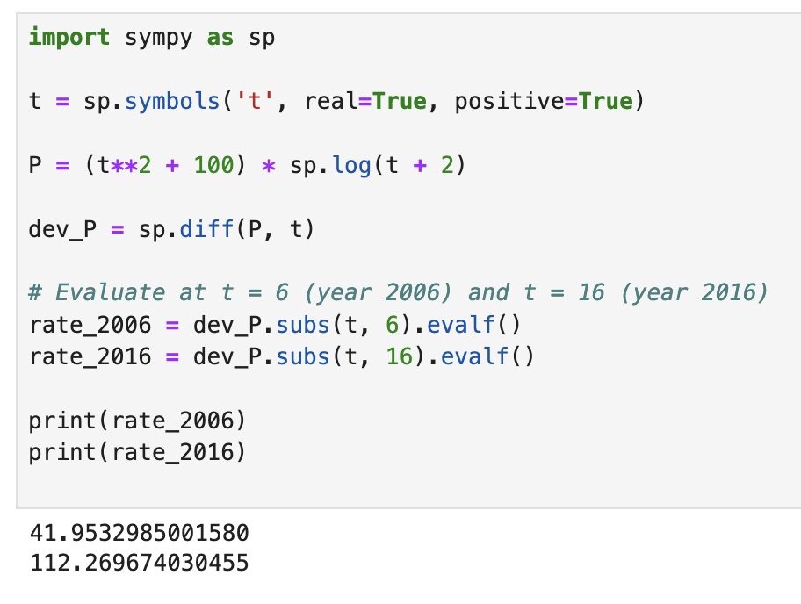
The rate of change for 2006 is 41 and the rate of change for 2016 is 112. I rounded down because people represent integers.
It probably breaks down after 2016 because growth accelerates indefinitely with an equation like this. It can’t grow exponentially forever because the population would have to also increase exponentially.

- The nationwide attendance per day for a certain pair of upcoming MCU blockbusters can be approximated using the equation $A\left(t\right)=\frac{12t^{5}}{2e^{t}+3t}$ where A is the attendance per day in thousands of people and t is the number of months since the release of the film. Find and interpret the rate of change of the daily attendance after 2 months, 4 months and 6 months. Based on this model, what will happen to attendance in the future and should the movie industry be concerned?

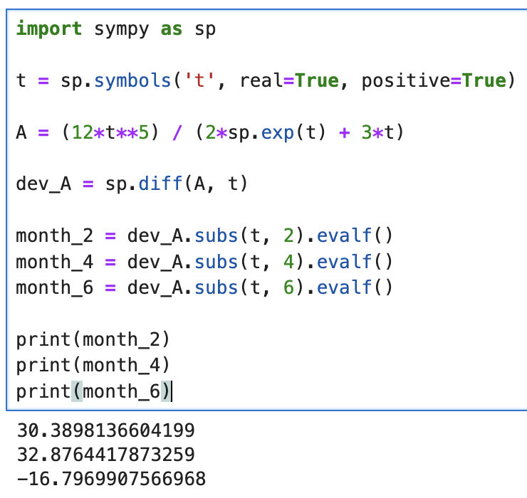
2 months: 30.39 thousand people per month
4 months: 32.88 thousand people per month
6 months: -16.8 thousand people per month
Attendance in the future will go down significantly and the movie industry should be concerned. It will eventually reach 0 because the denominator will be so big.

